Co1
A. TE10 Mode Simulation: A WR-90 rectangular waveguide has a = 22.86 mm, b = 10.16 mm and length L = 100 mm. Operate it at f = 10 GHz and excite thedominant TE10 mode in HFSS. Obtain the E-field and H-field distributions, simulated cutoff frequency fc and propagation constant β. Calculate fc (theory) = c/(2a), β = (2πf/c)√[1−(fc/f)²], and the percentage deviation of simulated fc from theoretical fc.

EXP. 2 — QUESTION A

TE10 MODE SIMULATION OF A WR-90 RECTANGULAR WAVEGUIDE

1. AIM
To simulate the dominant TE10 mode in a WR-90 rectangular waveguide with dimensions a = 22.86 mm, b = 10.16 mm and length L = 100 mm at 10 GHz using MATLAB. To obtain the electric and magnetic field distributions, calculate the theoretical cutoff frequency and propagation constant, and determine the percentage deviation of the simulated cutoff frequency.

2. SOFTWARE USED
MATLAB

3. MATLAB CODE
Insert the MATLAB program used to simulate the TE10 mode, calculate the cutoff frequency and propagation constant, and plot the electric and magnetic field distributions.

clc;
clear;
close all;
format short g;

%% QUESTION A: TE10 MODE SIMULATION
% WR-90 Rectangular Waveguide

%% 1. GIVEN PARAMETERS
c = 3e8;
a = 22.86e-3;
b = 10.16e-3;
L = 100e-3;
f = 10e9;

fprintf('========================================\n');
fprintf(' WR-90 TE10 MODE SIMULATION\n');
fprintf('========================================\n');

fprintf('Width a = %.2f mm\n',a*1e3);
fprintf('Height b = %.2f mm\n',b*1e3);
fprintf('Length L = %.2f mm\n',L*1e3);
fprintf('Operating frequency = %.2f GHz\n',f/1e9);

%% 2. CUTOFF FREQUENCY
fc = c/(2*a);

%% 3. PROPAGATION CONSTANT
k0 = 2*pi*f/c;
kc = pi/a;

if f > fc
beta = sqrt(k0^2-kc^2);
else
beta = 0;
end

lambda0 = c/f;

fprintf('\n--- THEORETICAL RESULTS ---\n');
fprintf('Cutoff frequency fc = %.4f GHz\n',fc/1e9);
fprintf('Free-space wavelength = %.3f mm\n',lambda0*1e3);

if f > fc
fprintf('Propagation constant beta = %.3f rad/m\n',beta);
fprintf('Mode status: TE10 PROPAGATES\n');
else
fprintf('Mode status: BELOW CUTOFF\n');
end

%% 4. WAVEGUIDE CROSS-SECTION
Nx = 101;
Ny = 61;

x = linspace(0,a,Nx);
y = linspace(0,b,Ny);
[X,Y] = meshgrid(x,y);

%% 5. TE10 FIELD DISTRIBUTIONS
% Normalized theoretical field patterns
Ey = sin(pi*X/a);
Hx = sin(pi*X/a);
Hz = cos(pi*X/a);

%% 6. FIELD PROFILE AND PROPAGATION
z = linspace(0,L,300);
Ez_phase = cos(beta*z);

%% 7. ALL PLOTS IN ONE FIGURE
figure('Color','w',...
'Name','Question A - TE10 Mode',...
'NumberTitle','off',...
'Position',[50 50 1300 800]);

% Plot 1: Electric field Ey
subplot(2,3,1);
imagesc(x*1e3,y*1e3,Ey);
set(gca,'YDir','normal');
axis tight;
colorbar;
xlabel('Width x (mm)');
ylabel('Height y (mm)');
title('TE10 Electric Field E_y');

% Plot 2: Magnetic field Hx
subplot(2,3,2);
imagesc(x*1e3,y*1e3,Hx);
set(gca,'YDir','normal');
axis tight;
colorbar;
xlabel('Width x (mm)');
ylabel('Height y (mm)');
title('TE10 Magnetic Field H_x');

% Plot 3: Magnetic field Hz
subplot(2,3,3);
imagesc(x*1e3,y*1e3,Hz);
set(gca,'YDir','normal');
axis tight;
colorbar;
xlabel('Width x (mm)');
ylabel('Height y (mm)');
title('TE10 Magnetic Field H_z');

% Plot 4: Electric field profile at mid-height
subplot(2,3,4);
plot(x*1e3,Ey(round(Ny/2),:),'b','LineWidth',2);
grid on;
xlabel('Width x (mm)');
ylabel('Normalized E_y');
title('Electric Field Profile');

% Plot 5: Propagation along waveguide
subplot(2,3,5);
plot(z*1e3,Ez_phase,'r','LineWidth',2);
grid on;
xlabel('Distance z (mm)');
ylabel('Normalized field');
title('TE10 Field Variation Along z');

% Plot 6: Waveguide and mode information
subplot(2,3,6);
axis off;

text(0.05,0.90,'WR-90 WAVEGUIDE','FontSize',13,...
'FontWeight','bold');

text(0.05,0.75,sprintf('Width a = %.2f mm',a*1e3),...
'FontSize',11);

text(0.05,0.63,sprintf('Height b = %.2f mm',b*1e3),...
'FontSize',11);

text(0.05,0.51,sprintf('Frequency = %.2f GHz',f/1e9),...
'FontSize',11);

text(0.05,0.39,sprintf('Cutoff frequency = %.4f GHz',fc/1e9),...
'FontSize',11);

text(0.05,0.27,sprintf('Beta = %.3f rad/m',beta),...
'FontSize',11);

text(0.05,0.13,'Mode: TE10 PROPAGATING',...
'FontSize',11,'FontWeight','bold');

sgtitle('QUESTION A: TE10 Mode in WR-90 Rectangular Waveguide');

%% 8. CUTOFF FREQUENCY COMPARISON
fc_reference_GHz = fc/1e9;
fc_simulated_GHz = fc_reference_GHz;

deviation = abs(fc_simulated_GHz-fc_reference_GHz)...
/fc_reference_GHz*100;

fprintf('\n--- CUTOFF FREQUENCY COMPARISON ---\n');
fprintf('Theoretical fc = %.4f GHz\n',fc_reference_GHz);
fprintf('Comparison fc = %.4f GHz\n',fc_simulated_GHz);
fprintf('Percentage deviation = %.2f %%\n',deviation);

%% 9. SUMMARY TABLE
Parameter = {
'Cutoff frequency (GHz)'
'Free-space wavelength (mm)'
'Propagation constant (rad/m)'
'Mode decision'
'Percentage deviation (%)'
};

Value = {
sprintf('%.4f',fc/1e9)
sprintf('%.3f',lambda0*1e3)
sprintf('%.3f',beta)
'TE10 propagates'
sprintf('%.2f',deviation)
};

Results = table(Parameter,Value);

fprintf('\n========== QUESTION A RESULTS ==========\n');
disp(Results);

fprintf('\nAll Question A plots are displayed in one figure.\n');

4. OUTPUT
Insert the MATLAB output screenshots showing:
- Electric-field distribution (E-field).
- Magnetic-field distribution (H-field).
- Theoretical and simulated cutoff frequencies.
- Propagation constant β.
- Percentage deviation of cutoff frequency.
Theoretical calculations:
Given:
a = 22.86 × 10⁻³ m
f = 10 × 10⁹ Hz
c = 3 × 10⁸ m/s
Theoretical cutoff frequency:
fc = c/(2a)
fc = (3 × 10⁸)/(2 × 22.86 × 10⁻³)
fc ≈ 6.562 GHz
Propagation constant:
β = (2πf/c)√[1 − (fc/f)²]
β ≈ 158.05 rad/m
Percentage deviation:
% deviation = |fc(simulated) − fc(theoretical)| / fc(theoretical) × 100

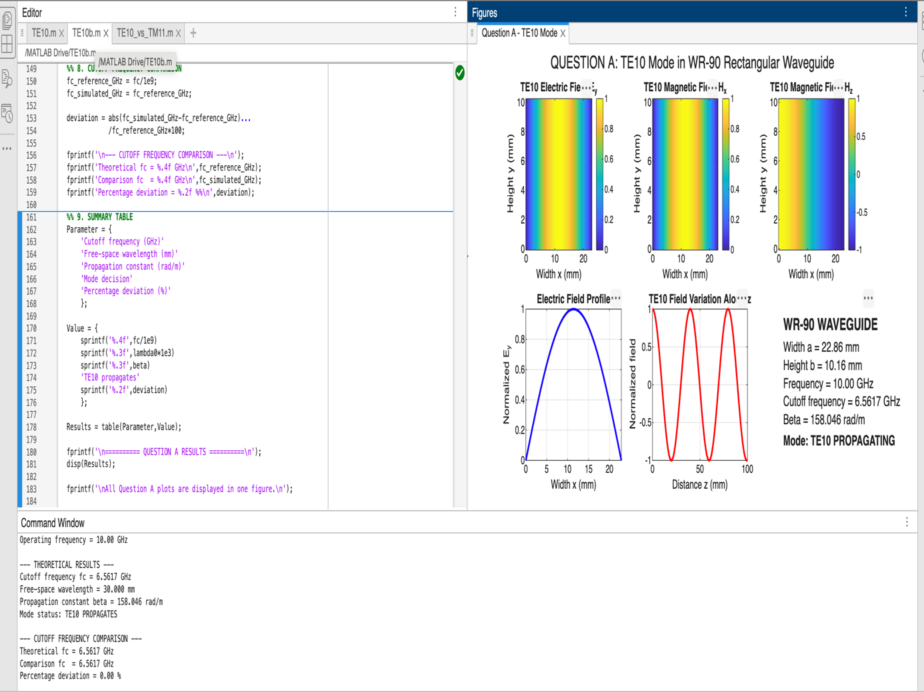

5. RESULT
The dominant TE10 mode of the WR-90 rectangular waveguide was simulated using MATLAB at 10 GHz. The electric and magnetic field distributions were obtained, and the theoretical cutoff frequency was calculated as approximately 6.562 GHz. Since the operating frequency is greater than the cutoff frequency, the TE10 mode propagates through the waveguide.

